

Sermon Notes

Name

Today’s Date

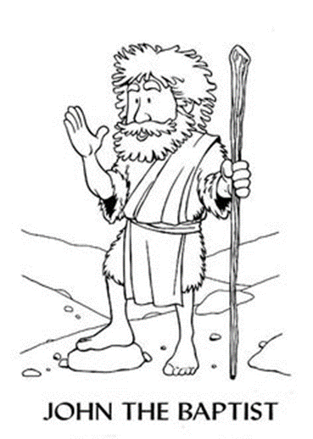

Read Luke 1:16-27, 35-36, 76 and Matthew 3:1, 4 to fill in the blanks:

John the Baptist:

Lived in the ____________________________

Was ______ months older than Jesus

Wore clothing of ___________ and _________

Ate ______________ and _________________

Prepared the way for _____________________

